**Department of (Computer Science)**

**Pak-Austria Fachhochschule: Institute of Applied Sciences and Technology, Haripur, Pakistan**

**COMP-112L Object Oriented Programming Lab**

**Lab Journal**

**Class: BS Computer Science**

**Name: Ahmed Raza**

**Registration No.: B20F0436CS031**

**Semester: 3rd**

**Submission Date: 08 February, 2022**

**Submitted to: Engr. Rafi-Ullah**

**__________________**

**Instructor Signature**

**Lab No. 08**

**Operating Overloading**

**Objectives:**

In this lab we will be discussing about Operator Overloading in detail. This is one of the most important concepts in Object Orientation. In C++ the overloading principle applies not only to functions, but to operators too. That is, of operators can be extended to work not just with built-in types but also classes.

**Tools/Software Required:**

* All the tasks are implemented on DEV C++.

**Introduction:**

**Operator Overloading**

A programmer can provide his or her own operator to a class by overloading the built-in operator to perform some specific computation when the operator is used on objects of that class. On the other hand, operator overloading, like any advanced C++ feature, makes the language more complicated. In addition, operators tend to have very specific meaning, and most programmers don't expect operators to do a lot of work, so overloading operators can be abused to make code unreadable.

**Assignment operator**

The assignment operator can be overloaded. We did not have to call any accessor functions in order to get the real and imaginary parts from the parameter other since the overloaded operator is a member of the class and has full access to all private data. Alternatively, we could have defined the addition operator globally and called a member to do the actual work.

**Lab Tasks:**

**Task # 01:**

Write a C++ program for the matric multiplication using operator overloading. Overload the operator (*) and solve matrix multiplication. Here are some key consideration that you keep in mind while developing solution.

In this task you will take a 3x3 matrix.

**Description**:

* Class Matrix has a constructor that will initialize its element to 0.
* Also has a set () function that can be used to set values in the Matrix.
* A show () function shows the matrix.
* Operator overloading definition for "*" operator.

**Code:**

**#include<iostream>**

**using namespace std;**

**class Matrix**

**{**

**private :**

**int a11;int a12;int a13;**

**int a21;int a22;int a23;**

**int a31;int a32;int a33;**

**int b11;int b12;int b13;**

**int b21;int b22;int b23;**

**int b31;int b32;int b33;**

**int z11;int z12;int z13;**

**int z21;int z22;int z23;**

**int z31;int z32;int z33;**

**public:**

**int MUL(int a[][3], int b[][3], int mul[][3])**

**{**

**//Initializing the all indexes of Mul matrix**

**for(int i = 0; i <3; ++i)**

**for(int j = 0; j <3; ++j)**

**{**

**mul[i][j]=0;**

**}**

**// Multiplying the both matrix to get result in Mul Matrix.**

**for(int i = 0; i <3; ++i)**

**for(int j = 0; j <3; ++j)**

**for(int k = 0; k<3; ++k)**

**{**

**mul[i][j] += a[i][k] * b[k][j];**

**}**

**return mul[3][3];**

**}**

**// SET FOR A**

**void set_a11(int c11){a11=c11;}**

**void set_a12(int c12){a12=c12;}**

**void set_a13(int c13){a13=c13;}**

**void set_a21(int c21){a21=c21;}**

**void set_a22(int c22){a22=c22;}**

**void set_a23(int c23){a23=c23;}**

**void set_a31(int c31){a31=c31;}**

**void set_a32(int c32){a32=c32;}**

**void set_a33(int c33){a33=c33;}**

**// SET FOR B**

**void set_b11(int d11){b11=d11;}**

**void set_b12(int d12){b12=d12;}**

**void set_b13(int d13){b13=d13;}**

**void set_b21(int d21){b21=d21;}**

**void set_b22(int d22){b22=d22;}**

**void set_b23(int d23){b23=d23;}**

**void set_b31(int d31){b31=d31;}**

**void set_b32(int d32){b32=d32;}**

**void set_b33(int d33){b33=d33;}**

**// SET FOR Z**

**void set_z11(int y11){z11=y11;}**

**void set_z12(int y12){z12=y12;}**

**void set_z13(int y13){z13=y13;}**

**void set_z21(int y21){z21=y21;}**

**void set_z22(int y22){z22=y22;}**

**void set_z23(int y23){z23=y23;}**

**void set_z31(int y31){z31=y31;}**

**void set_z32(int y32){z32=y32;}**

**void set_z33(int y33){z33=y33;}**

**//GET FOR A**

**int get_a11(){return a11;}**

**int get_a12(){return a12;}**

**int get_a13(){return a13;}**

**int get_a21(){return a21;}**

**int get_a22(){return a22;}**

**int get_a23(){return a23;}**

**int get_a31(){return a31;}**

**int get_a32(){return a32;}**

**int get_a33(){return a33;}**

**//GET FOR B**

**int get_b11(){return b11;}**

**int get_b12(){return b12;}**

**int get_b13(){return b13;}**

**int get_b21(){return b21;}**

**int get_b22(){return b22;}**

**int get_b23(){return b23;}**

**int get_b31(){return b31;}**

**int get_b32(){return b32;}**

**int get_b33(){return b33;}**

**// GET FOR Z**

**int get_z11(){return z11;}**

**int get_z12(){return z12;}**

**int get_z13(){return z13;}**

**int get_z21(){return z21;}**

**int get_z22(){return z22;}**

**int get_z23(){return z23;}**

**int get_z31(){return z31;}**

**int get_z32(){return z32;}**

**int get_z33(){return z33;}**

**};**

**int main()**

**{**

**Matrix C1;**

**int a[3][3];**

**int b[3][3];**

**int mul[3][3];**

**int r11,r12,r13,r21,r22,r23,r31,r32,r33;**

**int t11,t12,t13,t21,t22,t23,t31,t32,t33;**

**int result11,result12,result13,result21,result22,result23,result31,result32,result33;**

**cout<<"FOR THE FIRST MATRIX "<<endl;**

**for(int i=1; i<=3; i++)**

**{**

**for(int j=1; j<=3; j++)**

**{**

**cout<<"Enter value in a"<<i<<j<<" : ";**

**cin>>a[i-1][j-1];**

**cout<<endl;**

**}**

**}**

**cout<<"FOR THE SECOND MATRIX "<<endl;**

**for(int i=1; i<=3; i++)**

**{**

**for(int j=1; j<=3; j++)**

**{**

**cout<<"Enter value in a"<<i<<j<<" : ";**

**cin>>b[i-1][j-1];**

**cout<<endl;**

**}**

**}**

**//Set for A**

**C1.set_a11(a[0][0]);C1.set_a12(a[0][1]);C1.set_a13(a[0][2]);**

**C1.set_a21(a[1][0]);C1.set_a22(a[1][1]);C1.set_a23(a[1][2]);**

**C1.set_a31(a[2][0]);C1.set_a32(a[2][1]);C1.set_a33(a[2][2]);**

**//Set for B**

**C1.set_b11(b[0][0]);C1.set_b12(b[0][1]);C1.set_b13(b[0][2]);**

**C1.set_b21(b[1][0]);C1.set_b22(b[1][1]);C1.set_b23(b[1][2]);**

**C1.set_b31(b[2][0]);C1.set_b32(b[2][1]);C1.set_b33(b[2][2]);**

**C1.MUL(a,b,mul);**

**C1.set_z11(mul[0][0]);C1.set_z12(mul[0][1]);C1.set_z13(mul[0][2]);**

**C1.set_z21(mul[1][0]);C1.set_z22(mul[1][1]);C1.set_z23(mul[1][2]);**

**C1.set_z31(mul[2][0]);C1.set_z32(mul[2][1]);C1.set_z33(mul[2][2]);**

**// Getting values from array A**

**r11=C1.get_a11();r12=C1.get_a12();r13=C1.get_a13();**

**r21=C1.get_a21();r22=C1.get_a22();r23=C1.get_a23();**

**r31=C1.get_a31();r32=C1.get_a32();r33=C1.get_a33();**

**// Getting values from array B**

**t11=C1.get_b11();t12=C1.get_b12();t13=C1.get_b13();**

**t21=C1.get_b21();t22=C1.get_b22();t23=C1.get_b23();**

**t31=C1.get_b31();t32=C1.get_b32();t33=C1.get_b33();**

**// Getting values from array C**

**result11=C1.get_z11();result12=C1.get_z12();result13=C1.get_z13();**

**result21=C1.get_z21();result22=C1.get_z22();result23=C1.get_z23();**

**result31=C1.get_z31();result32=C1.get_z32();result33=C1.get_z33();**

**cout<<"\tFIRST MATRIX IS "<<endl;**

**cout<<"\t"<<r11<<"\t"<<r12<<"\t"<<r13<<endl;**

**cout<<"\t"<<r21<<"\t"<<r22<<"\t"<<r23<<endl;**

**cout<<"\t"<<r31<<"\t"<<r32<<"\t"<<r33<<endl;**

**cout<<"\tSECOND MATRIX IS "<<endl;**

**cout<<"\t"<<t11<<"\t"<<t12<<"\t"<<t13<<endl;**

**cout<<"\t"<<t21<<"\t"<<t22<<"\t"<<t23<<endl;**

**cout<<"\t"<<t31<<"\t"<<t32<<"\t"<<t33<<endl;**

**cout<<"\tMULTIPLE MATRIX IS "<<endl;**

**cout<<"\t"<<result11<<"\t"<<result12<<"\t"<<result13<<endl;**

**cout<<"\t"<<result21<<"\t"<<result22<<"\t"<<result23<<endl;**

**cout<<"\t"<<result31<<"\t"<<result32<<"\t"<<result33;**

**return 0;**

**}**

**Output:**

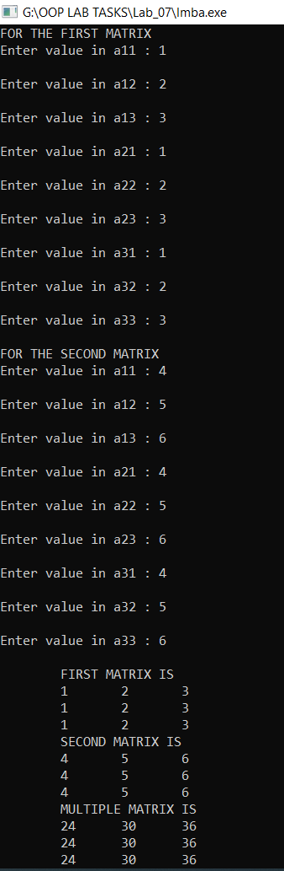

**Task #02:**

Write a C++ program to overload the plus operator by using the concept of operator overloading. There must be a class having default constructor. Create three objects of the class and store the addition of two objects in third object, also include print function to print the variables.

**Code:**

**#include<iostream>**

**using namespace std;**

**class Oper_Overload {**

**int num;**

**public:**

**void set_num(int s) {**

**num = s;**

**}**

**Oper_Overload operator+(Oper_Overload ob) {**

**Oper_Overload t;**

**t.num = num + ob.num;**

**return (t);**

**}**

**void display() {**

**cout << num << endl;**

**}**

**};**

**int main() {**

**Oper_Overload num1, num2, result;**

**int a, b;**

**cout << "Enter the value of Complex Numbers a: ";**

**cin >> a;**

**cout << "Enter the value of Complex Numbers b: ";**

**cin>>b;**

**num1.set_num(a);**

**num2.set_num(b);**

**result = num1 + num2 ;**

**cout << "Input Values:\n";**

**num1.display();**

**num2.display();**

**cout << "Result is: ";**

**result.display();**

**return 0;**

**}**

**Output:**

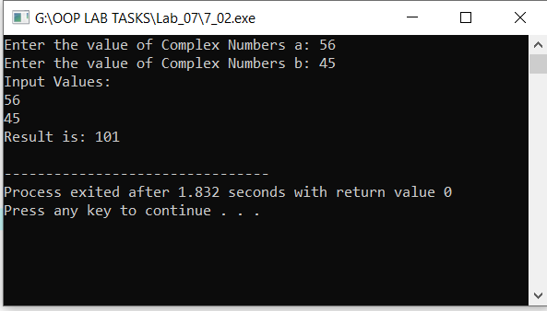

**Results & Observations:**

In this Lab I’ve learned about the concept of operator overloading & also I understand the concept of friend function that how can we use friend function in the class. As well as I learned about static keywords and static member variables. In the first task, I’ve used a Class with name Matrixin which I’ve used Mul function that’s taking two arrays from the main function and multiply both and return it after saving it in the third array. In the second task, I’ve used the operator overloading concept then in the main function I’ve created three objects of the Oper-Overload class through which I’ve accessed data from the class.